Revisions approved by SRS Academic Affairs Committee Nov 18, 2022; reviewed and approved by CGPS May 17, 2022
First approved by School of Rehabilitation Science Academic Affairs Committee Feb. 08, 2019

PREAMBLE:
This document is complementary to, and does not replace nor contradict College of Graduate and Postdoctoral Studies (CGPS) policies regarding Professional Conduct, the School of Rehabilitation Science (SRS) policy for Academic Expectations, Advancement and Promotion and/or the University of Saskatchewan regulations and standards for academic and non-academic matters (see below). As described in the SRS’s policy regarding professional behaviour and expectations, https://medicine.usask.ca/policies/professional-behaviours-and-expectations.php, acceptance into the SRS Master of Physical Therapy program indicates that students are prepared to assume the responsibilities of a graduate level student and a physical therapy professional. These responsibilities include a commitment to personal and professional growth and a willingness to accept responsibility for one’s professional and personal actions. Professional behaviours and values are core elements in the effective and appropriate practice of all health care delivery and form the basis for all interactions. Each MPT student is expected to demonstrate a commitment to learning and professional behaviors regardless of setting (academic or clinical) throughout the program. This procedural document works congruently with the development and evaluation of professionalism embedded within course evaluation. Professional behaviours are an important essential competency standard for entry to practice professional Colleges and Schools. This document provides guidance to students, faculty, and staff on processes to address, mentor and re-mediate the development of professionalism throughout the program.

2. PURPOSE:
The purpose of the Procedures for Concerns with Masters Physical Therapy (MPT) Student Professional Behaviour is to describe the implementation of the Regulations on Student Academic Misconduct and Standard of Student Conduct in Non-Academic Matters and Regulations and Procedures for Resolution of Complaints and Appeals, University of Saskatchewan within the SRS, College of Medicine (COM) and the CGPS at the University of Saskatchewan. This Standard Operating Procedure (SOP) provides transparent processes for responding to concerns of lapses in professional behaviour by physical therapy students and serves as a learning tool to assist students to recognize and address professional behaviour expectations necessary to attain and maintain licensure as a physical therapist. The educators in our program highly value the importance of training PT students to acknowledge and internalize professionalism in health care. The procedures are structured to be consistent with the Harmonized Code of Ethical Conduct for Registered Physiotherapists in Canada, the Canadian Physiotherapy Association Code of Ethics, the Essential Skills and Attributes required to study in the Masters of Physical Therapy (MPT) program and the NPAG Competency Profile for Physiotherapists in Canada (2017). It is the expectation that physical therapy students as junior colleagues and members of the profession are held accountable to the same standards as professionals in the physical therapy field. Professional behaviour evaluation in the MPT program is embedded in both academic and clinical courses and meeting expectations is a requirement for promotion and advancement in the program. Lapses in professional behaviour are monitored through the SRS Academic Affairs Committee, the Director of the SRS, and communicated further as per the processes described below.
These procedures ensure that the MPT Program meets or exceeds the standards for accreditation by Physiotherapy Education Accreditation Canada.

SCope
These procedures apply to instances where graduate students registered in the MPT program at the University of Saskatchewan, engage in behaviour which is generally recognized as being unprofessional.

Definitions
Reporter: a person who submits a report of unprofessional behaviour. Typically, this will be an instructor of a MPT academic course, a guest lecturer, tutor or experiential learning coordinator or facilitator, clinical education coordinator or clinical instructor. This may also include a staff member in the SRS or Health Authority or other physical therapy or health professional students.
Respondent: a person alleged to have engaged in unprofessional behavior. This will typically be a graduate student registered in the MPT program at the University of Saskatchewan. Unprofessional behavior of students on visiting clinical placements or academic exchange placements will be reported to the Director or similar designation at the student’s home institution for management.
Minor Incident: an incident that has minimal consequence. Examples of unprofessional behaviour include but are not limited to:
- Submitting an assignment late or missing a deadline without prior approval from the instructor or in the case of an emergency, failing to notify anyone.
- Demonstrating a habit of being late for class and disrupting the classroom environment.
- Arriving late for or missing a lecture, tutorial, lab, or clinical learning experience without notifying anyone or offering an explanation in the event of an unexpected circumstance.
- Failing to adhere to attendance policies regarding requests for longer absences.
- Presenting an appearance that may be perceived by patients, staff, faculty, or a facility manager as unprofessional.
- Using language in email, assignment or other communication that may be overly casual or may be perceived as inappropriate and/or disrespectful.
- Receiving or responding to feedback inappropriately.
- Failing to promptly return phone calls and emails, or other communication unrelated to patient care.
- Incidents of academic misconduct in which the reporter perceives that the student’s misconduct was minor and unintentional, resulting from misunderstanding or carelessness, and may be better addressed through informal measures (U of S Regulations on Student Academic Misconduct, effective Jan 1, 2017).

Major Incident: an incident that has the potential for serious personal or clinical consequences for others, including patients. Examples of unprofessional behaviour include but are not limited to:
- Failing to communicate in a timely manner when patient care may be compromised or within a requested time frame and no extenuating circumstances are identified.
- Demonstrating dishonest behavior including lying, misrepresenting oneself, cheating or falsifying information that is related to the student’s area of professional practice, as per Section A in the U of S Regulations on Academic Misconduct
- Posting patient, peer or faculty information on a social networking website that should not be exposed to the public domain (may be considered a critical lapse depending on severity and intent).
- Sharing patient information in a public space or with anyone outside of the circle of care.
- Engaging in inappropriate and/or offensive communication with colleagues.
- Communicating in an inappropriate manner, whether on social media/ internet, in person or other means including shaming others publicly, exhibiting uncontrolled anger, demonstrating disrespect or discrimination based on race, ethnicity, sex, sexual orientation or sexual identity, gender identification, disability, religion, age, or nationality; displaying inappropriate pictures from research, education or clinical settings through social media;
- Communicating in an inappropriate manner may also include the use of unacceptable words, images, or actions such as profane or disrespectful language; inappropriate labels or name-calling; patronizing and insulting remarks; intimidating actions such as slamming doors or throwing things;
- Uncooperative behaviors, whether intentional or not, such as repeated refusals to comply with known and accepted practice standards;
- Refusing to work collaboratively with colleagues, staff and patients.

Critical Incident: an incident which has direct harmful consequences or is an egregious breach of well-recognized standards. These are clear violations of the Code of Ethical Conduct for Registered Physiotherapists in Canada. These incidents are addressed through the Regulations on Student Academic Misconduct and Standard of Student Conduct in Non-Academic Matters and Regulations and Procedures for Resolution of Complaints and Appeals, University of Saskatchewan (refer to 6.3). Examples include but are not limited to:
- Physically or sexually assaulting a patient, peer, clinical preceptor, faculty, or staff member.
- Being sexually inappropriate with a patient, peer, clinical preceptor, faculty, or staff member.
- Unwelcome and inappropriate verbal, written, graphic or physical conduct, or coercive behavior, where the behavior is known or reasonably ought to be known to be unwelcome
- Unauthorized release of confidential information including identifiable personal data of a research participant; a patient’s health information or other breach of personal information, privacy policy and Freedom of Information and Protection of Privacy Act (FOIP), the Local Authority Freedom of Information and Protection of Privacy Act (FIPPA), Health Information Protection Act (HIPA).
- Inappropriately accessing or using the personal information of a co-worker, learner, research participant or patient.

Guiding Principles
In the teaching and learning of physical therapy, professionalism is a core academic competency and is continuously being assessed throughout the program. MPT courses and clinical placements include professionalism as a component to be taught and evaluated. These procedures are not intended to override course-related assessment processes or documentation. The primary intention of these procedures is to provide an effective mechanism for the early identification of students who need assistance with their professional development so that appropriate mentorship and education can be implemented in support of their successful completion of the program. They should be considered when unprofessional conduct is identified that is outside the developmental norms for a student’s cohort. The secondary intention of these procedures is to assist with crucial academic decisions when remediation is unsuccessful or inappropriate.
These procedures cover most concerns with professional behaviour that occur in academic, research or clinical settings or other SRS events, projects or activities that are related to the student's area of professional study and are informed by the following guiding principles identified by the Code of Ethical Conduct for Registered Physiotherapists in Canada and the SRS mission and values statements.
Specifically, the SRS is committed to acting in accordance with the following values: Respect for others, Fair and Equitable Treatment, Honesty, Integrity and Ethical Behaviour, Empathy and Compassion and Professional Responsibility. The Harmonized Code of Ethical Conduct outlines Responsibilities to the Client, the Public, the Self, and the Profession. These ethical responsibilities are transferable to all levels of communication and engagement during the course of studies in the MPT program. These responsibilities are summarized below linked to our core values:
Respect for others
Professionals demonstrate consideration and respect for others including patients, their families and support persons, colleagues, classmates, teachers, other professionals, and the public.
- We demonstrate respect for the dignity and rights of clients and their families or support persons, considering their diversities, both in their presence and in discussion with other members of the health care team.
- We accept and promote client autonomy in decision--‐making, and when the client lacks capacity, we consult with and appropriately take direction from surrogate decision-makers.
- We respect the personal boundaries of others and refrain from making unwanted or inappropriate romantic or sexual overtures towards others.
- We communicate respectfully with others both verbally and in writing.
- We respect the privacy and confidentiality of those to whom we owe that duty.
- We demonstrate sensitivity toward people we interact with, respecting and taking into consideration their unique rights, needs, beliefs, values, culture, goals, and environmental context.
- We respect the principles of informed consent including by explaining service options, risks, benefits, potential outcomes, possible consequences of refusing treatment or services, and by avoiding coercion.
- We use electronic communication and social media and other forms of digital technology professionally and respectfully, conforming to confidentiality guidelines.
- We don't discriminate against others on the basis of such grounds as race, ethnicity, sex, sexual orientation or sexual identity, gender identification, disability, religion, age, political beliefs, family status or nationality.
Honesty, Integrity, and Ethical Behaviour
Professionals demonstrate adherence to the highest standards of personal, professional, and academic honesty and integrity.
- We communicate truthfully with others verbally and in writing.
- We don't falsify documents or records.
- We acknowledge and manage conflicts of interest appropriately, avoiding conflicts of interest, real or apparent, whenever there is potential detriment to others.
- We admit and disclose errors.
- We make accurate records of conversations, histories, physical findings, and other information pertinent to patient care.
- We don't engage in plagiarism, cheating in any form, nor do we give or receive assistance during an examination or in completion of an assignment unless such is expressly permitted.
- We conduct research in an ethical manner, analyzing and reporting results accurately and fairly.
- We credit the ideas and work of others appropriately and fairly.
- We comply with all legislation, guidelines, and regulatory requirements that pertain to the profession of physiotherapy.
- We are professionally and morally responsible for addressing incompetent, unsafe, illegal, or unethical practice of any health care provider, or fellow student colleagues and we are legally responsible for reporting conduct that puts the client at risk to the appropriate authority/ies.
Compassion and empathy
Professionals demonstrate compassion and empathy for those in distress and especially for patients, their families and support persons.
- We demonstrate effective listening.
- We are aware of and respectful of others' differences and respond appropriately to their needs.
- We show compassion and provide support for patients, their families and support persons dealing with illness and/or dying and death.

Professionalism: Duty and Responsibilities
Professionals acknowledge their duties to clients, their profession and the public and accept the responsibilities that flow from these duties.
- We attend to clients’ best interests and well-being as the priority, advocating within their capacity and the broad determinants of health to improve the standards of health care.
- We work cooperatively with others for the benefit of our patients and contribute to a healthy working environment for all.
- We make equitable and prudent use of health care resources under our control
- We are responsible to society for matters relating to public health.
- We recognize and adhere appropriately to policies, codes, guidelines, and laws that govern us and our work.
- We participate in the process of self-regulation of the profession.
- We address misconduct, incompetence or behaviours that put clients or others at risk
- We share resources and expertise and assume responsibility for our portion of a fairly distributed workload; where issues of fair distribution arise, we act most immediately in the client's best interests, and seek to resolve issues of fairness through appropriate channels.
- We respond in an appropriate, non-judgmental, and non-demeaning manner when our expertise is sought.
- We don't take advantage of colleagues, learners, patients, their families or support persons or others for emotional, financial, sexual, or other personal purposes, and we conduct research and educational activities with these groups only with appropriate informed consent.
- We fulfill commitments, meet deadlines and are punctual particularly where these behaviours have significant impact on others; where we're unable to do so, we communicate appropriately to mitigate any negative impacts.
- We engage in lifelong learning, maintain clinical competence, and strive for continuous quality improvement.
- We take appropriate and necessary responsibility for our personal health and well-being.
- We recognize our own limitations and seek assistance appropriately.
- We display dress, behaviour, and demeanor in the educational and healthcare setting in keeping with appropriate pedagogical, clinical or safety standards.
*Adapted and Used with Permission from the University of Saskatchewan College of Medicine Undergraduate Program SOP for Unprofessional Behaviour.
The SRS Director for the MPT is responsible for the oversight and implementation of the Procedure for Concerns with MPT Student Professional Behaviour, in consultation with the SRS Academic Affairs Committee.

SPECIFIC PROCEDURE

Reporting a Minor Incident
Many cases of concern for professional behaviour on the part of students result from misunderstanding or lack of familiarity with the expected standards. Examples of minor incidents are indicated in 3.0 Definitions. A case of this kind can often be addressed through an informal meeting with the student (respondent) by a reporter who first identifies the issue (Appendix A). The reporter should arrange a meeting to discuss the situation or incident. The student has the option to invite the SRS Student Affairs Coordinator to attend the meeting. Generally, a conversation and feedback may be sufficient. It may also be reasonable to expect that the student will address the issue in a manner mutually agreed upon. The reporter will document the discussion with the student and complete an Informal Discussion Form. The student will be provided a copy in order to document their understanding of the discussion. The Informal Discussion Form will be submitted to the SRS Director who will maintain a confidential file of these forms within the Academic Affairs confidential file (electronic).

The SRS Director will track receipt of Informal Discussion Forms that had been incurred by the students that have not met the threshold for a Professionalism Concern Form. This would include students who have received 2 or less Informal Discussion Forms. Should a pattern of behaviour be identified (example a 2nd minor incident), the student will be contacted by the Director to arrange a meeting. The student has the option to invite the SRS Student Affairs Coordinator to attend the meeting. No action may be taken at this time, or the Director may report the pattern of behaviour to the SRS Academic Affairs Committee and a plan for ongoing professional guidance and mentorship may be formulated by the SRS Academic Affairs Committee. This will be recorded in the Academic Affairs Committee in-camera minutes and will be stored in the student’s confidential Academic Affairs file.

If at any point during the program, a student incurs multiple (three or more) Informal Discussion Forms of a similar type (e.g. late assignments) or multiple (three or more) Informal Discussion Forms of different types (e.g. 1 late assignment, 1 episode of disrespectful communication, 1 episode of non-adherence to attendance policy), the Director will meet with the student. The Student Affairs Advisor may also be invited to attend, if agreed by the student. The Director will document the meeting and will complete a Professionalism Concern Form. The student will have an opportunity to include a comment in the Report. The Professionalism Concern Form will be submitted to SRS Academic Affairs Committee for consideration. The Professionalism Concern Form and any report or correspondence by Academic Affairs Committee will be recorded in the Academic Affairs Committee in-camera minutes and will be stored in the student’s confidential Academic Affairs file.

If a student incurs a subsequent minor incident after receiving a Professionalism Concern Form, a second Professionalism Concern Form will be completed, and a meeting will be arranged with the Director to discuss. The SRS Student Affairs Coordinator may also be invited to attend, if agreed by the student. The SRS Director will inform the student that a consultation about the matter will be made to the College of Medicine Professional Conduct Committee (PCC). The PCC will meet to determine whether a Formal Professionalism Hearing is required. If the PCC determines that a Formal Hearing is not required, the student will receive correspondence indicating the discussion and identified plan resulting from the meeting. Based on the recommendations from PCC, the Director will meet with the student to discuss a plan to address the concerns. If the PCC determines that a Formal Hearing is required, then the student will be notified, and a Hearing will be held. The process for a Formal Hearing of the PCC is described in 6.4. The PCC’s decision and recommendations will be communicated to the Director and subsequently to SRS Academic Affairs and the Associate Dean of CGPS. All correspondence and recordings will be kept on the SRS student record.

Reporting a Major Incident
A Major Incident is one that has the potential for serious consequences to patients, peers, staff, and faculty. A Major Incident may also include incidents that have the potential to damage the reputation of the SRS. Examples of Major Incidents can be found in 3.0 Definitions as well as defined in Section B of the U of S Regulations on Student Academic Misconduct. The procedure for reporting a Major Incident is shown in Appendix B. When a student is alleged to have engaged in a Major Incident, the reporter submits an Informal Discussion Form to the Director, who subsequently meets with the student to discuss the incident. The Director will document the meeting and will complete a Professionalism Concern Form. The student will have an opportunity to include a comment in the Report.
The Director will inform the student that a consultation about the matter will be made to the PCC. The PCC will meet to determine whether a Formal Professionalism Hearing is required. If the PCC determines that a Formal Hearing is not required, the student will be notified and student will have a follow-up meeting with the Director. If the PCC determines that a Formal Hearing is required, then the student will be notified, and a Hearing will be held. The process for a Formal Hearing of the PCC is described in 6.4. The PCC’s decision and recommendations will be communicated to the Director and subsequently to SRS Academic Affairs and the Associate Dean CGPS.

Reporting a Critical Incident
A Critical Incident is an incident which has direct harmful consequences or is an egregious breach of well-recognized standards. Because of the nature of the incidents as evidenced by the examples identified in 3.0 Definitions, the reporting of a Critical Incident will follow the processes utilized in the University of Saskatchewan Regulations on Student Academic Misconduct (2017) and Standard of Student Misconduct in Non-Academic Matters and Regulations & Procedures for Resolution of Complaints and Appeal (2016).
The procedure for reporting a Critical Incident is shown in Appendix C. When a student is alleged to have engaged in a Critical Incident, the reporter submits a Professionalism Concern Form to the Director who will report the concern to the SRS Academic Affairs Committee. If the Committee agrees there is evidence of a critical incident, then they will file a formal complaint pursuant to CGPS policies and the University of Saskatchewan Regulations on Student Academic Misconduct (2017) and Standard of Student Misconduct in Non-Academic Matters and Regulations & Procedures for Resolution of Complaints and Appeal (2016). The relevant university-level regulations are as follows:
- University of Saskatchewan Regulations on Student Academic Misconduct (2017)
- University of Saskatchewan Standard of Student Misconduct in Non-Academic Matters and Regulations & Procedures of Complaints and Appeal (2016)

If the Critical Incident has the potential to significantly impact the safety or wellbeing of others, particularly patients, the Director may interrupt the participation of the student in clinical activities or clinical courses pending investigation of the allegations.

Process for a Formal Hearing of the COM Professional Conduct Committee

All Committee proceedings should be based on sound principles to ensure a fair hearing within a reasonably short period of time. The respondent is to be treated as innocent until proven guilty and there must be the both the perception and reality that all hearings are fair and transparent. The primary goal of the process should be educational, leading to the successful remediation of unprofessional conduct and the subsequent successful completion of the program.

The Committee is to receive the evidence, determine the validity of the allegation and, if warranted, determine, implement, and monitor appropriate remedial action. The Committee may also determine academic repercussions. Where possible, the Committee will meet within four weeks from receipt of the Professionalism Concern Form.

The SRS Director will write to the respondent as soon as possible advising him/her of the allegation, the date and place of his/her meeting with the Committee and the Committee membership so that potential conflicts of interest can be identified. This notice will consist of both a letter to the respondent’s current postal address on file with the University and an email to the respondent’s usask email account. The respondent will be provided with approximately 2 weeks’ notice of the meeting date.

All information provided to the Committee in writing in advance of the meeting by any party should be shared in advance with the other parties appearing before the Committee in advance of the meeting.
The Professional Conduct Committee is a standing committee of the College of Medicine’s Faculty Council and is composed of a chairperson who is an MD faculty member and two additional members of the faculty of the college, at least one of whom will be an MD, as well as two faculty from the School of Rehabilitation Sciences. SRS faculty members are determined by the Director, in consultation with faculty during Assignment of Duties processes for a 3-year term and may be re-appointed for a second term. Faculty representation could include tenure-track faculty, lecturer, clinical specialist, or clinical faculty appointments. It is recommended that at least one Committee member be a licensed physical therapist with experience in the assessment of professionalism through prior or current participation in clinical education experiences. The Committee maintains its own records, separate from respondents’ academic files.
Membership for a hearing for an SRS student will include:
- the two SRS faculty,
- one MD or Biomedical Science faculty member, and
- one MPT student who is chosen by the SRS Director, in consultation with the Physical Therapy Student Society (PTSS) executive
The SRS Director, in consultation with the PTSS, will appoint to the Professional Conduct Committee a more senior student from the MPT program or, in the case of a respondent who is a final year student, a recent graduate pf the MPT program. The selection of the student or recent graduate may be challenged by the respondent if there is reasonable apprehension of bias or conflict of interest. Further, the respondent may choose to waive the requirement for student representation.
The Committee will meet with the respondent and the reporter at the same time. The Committee may, at its discretion, meet with any other person who, in the opinion of the Committee, can provide relevant evidence bearing on the matter. The Committee may set its own procedures. A suggested order of proceeding is as follows: The reporter outlines the evidence before the Committee followed by questions and points of clarification asked by the Committee members. The respondent is then allowed to express his/her side of the question followed again by questions and points of clarification asked by the Committee members. Questions for clarification purposes may then also be asked through the Committee chair by the respondent and by the reporter. After all questions have been answered and all points made, the Committee will meet in camera to decide on the question of validity and, if valid, an appropriate response/remediation plan. The decision and plan, if applicable, will be communicated to the respondent and the reporter in writing as soon as is possible after the hearing. The respondent and the reporter will be advised that either may appeal by the process identified in Section 6.5.
At the hearing, the respondent has the right to be accompanied by another person of his/her choice. The Office of Student Affairs is available for this purpose, but the respondent may make a different choice. This may include a class representative who may serve as support or character reference.
Similarly, the reporter may be accompanied by a person of his/her choice. On request, the Director will provide information and assistance in the identification of a suitable escort who is familiar with the procedures associated with this policy.
If the respondent does not respond to the written/email notification of the hearing, or refuses to appear before the Committee, or does not attend the hearing, the Committee has the right to proceed with the hearing. It is obviously in the respondent’s interests to be present for the hearing, but the Committee should not be prevented from holding a hearing because the respondent has not appeared.
When the reporter is a not a member of the university community, and with the agreement of the Committee members, the respondent may waive the requirement that the reporter be present in person; this assumes that the written documentation is clear and uncontested. In addition, a teleconference or a videoconference may be considered.
In circumstances in which the reporter is particularly vulnerable, the Chair of the Professional Conduct Committee may, at his/her discretion, permit the reporter to name a proxy to act on the reporter’s behalf.
When a set of circumstances has led to allegations of unprofessional conduct against two or more respondents, the investigation may include an opportunity for any or all the respondents to be interviewed separately. In a case where the unprofessional conduct is ascribed to a group of students, the Committee will try to determine if one person is responsible, or whether varying degrees of responsibility can be delineated. If individual responsibility cannot be determined, the whole group may be sanctioned.
If a majority of members of a Committee conclude that the allegation of unprofessional conduct is supported by the evidence before the Committee, it may recommend one or more of the following responses:
- that a remediation plan specific to the issues at hand be implemented, to be developed and monitored by the Committee;
- that there be a referral for assessment of possible medical and/or psychosocial issues at play, to be reported back to the Committee for further action and/or referral as necessary;
- that there be a record of the event(s) placed in the respondent’s SRS and CGPS academic file;
- that there is a recommendation made to the SRS Director and SRS Academic Affairs Committee for academic consequences such as requirement to re-submit an assignment, re-write an exam, that a mark of zero or other appropriate grade be assigned for an assessment, module or course, or that a credit or mark for the module or course be modified or cancelled;
- that a recommendation is made to SRS Academic Affairs and subsequently to CGPS that the respondent be required to repeat the year of the MPT program during which the unprofessional conduct was identified;
- that a recommendation for a requirement to discontinue the program is sent to SRS Academic Affairs for consideration, is communicated to the student via a meeting, is and subsequently sent to CGPS for consideration.
When determining the appropriate response, the Committee will take into account responses imposed for similar unprofessional conduct as recorded by the Director, as well as any record of previous reports of unprofessional conduct by the respondent(s). It is intended that most incidents be addressed in a remedial fashion, without adverse impact on the respondent’s academic progress or record. However, repeated, and refractory unprofessional conduct, or single incidents of particularly egregious conduct, may lead to the recommendation for academic repercussions as delineated above.
The chairperson of the Committee will prepare a report of the board's deliberations which will summarize the evidence on which the board based its conclusion that unprofessional conduct occurred and state the recommended response(s). Not later than 15 days after the Committee has completed its deliberations, the chairperson will deliver a copy of the report to the following persons:
- to the respondent;
- to the reporter (where there are multiple reporters only relevant portions of the report will be shared)
- to members of the Committee
- to the SRS Director and Chair of SRS Academic Affairs Committee;
When a PCC concludes that an allegation is not supported by the evidence, the report will so state. A recommendation of a PCC is not adopted until there is a decision by the SRS Academic Affairs. If the final recommendation from SRS Academic Affairs is to recommend a RTD, appropriate processes as outlined in the SRS policy for Academic Advancement and CGPS Policy and Procedures will be employed.
The process for a formal hearing of the Professional Conduct Committee (PCC) is congruent with the approved processes within the CGPS. Deviations in process specific to the SRS take into account the oversight and decision-making of the SRS Academic Affairs Committee and CGPS.
Appeals Process
Decisions made by the SRS Academic Affairs Committee, based on recommendations from the PCC may be appealed as per SRS, CGPS, and U of S policy and procedures.

Professionalism Files
Professionalism files are securely stored, in physical or electronic format, in the office of the Director. They are retained for the entire duration of a MPT student’s academic program and are destroyed two years after a student’s graduation, dismissal, withdrawal, or death.

Communicating the Procedures
The SRS will communicate the Procedure for Concern with SRS Student Professional Behaviour to faculty, staff, and students by ensuring that up-to-date versions of this procedure is publicly available on the college website. The SOP will be reviewed and updated by the SRS Academic Affairs Committee.
Furthermore, all students will verify that they have reviewed the document by signing a form signifying they have read the document and submit the form with their signature during orientation week.

forms/Templates to be used
Informal Discussion Form
Professionalism Concern Form
Appendix A – Minor Incident
Appendix B – Major Incident
Appendix C – Critical Incident

internal and external references

Internal References
Regulations on Student Academic Misconduct
Standard of Student Conduct in Non-Academic Matters and Regulations and Procedures for Resolution of Complaints and Appeals

External References
Dalhousie Medical School Professionalism Committee Professionalism Policy
Queen’s University Rehabilitation Therapy Education Student Professionalism Policy
Harmonized Code of Ethics for Canadian Physical Therapists
Saskatchewan College of Physical Therapists - Regulatory Bylaws

Appendix A: Procedures for Concerns with Physical Therapy Student Professional Behaviour Minor Incident
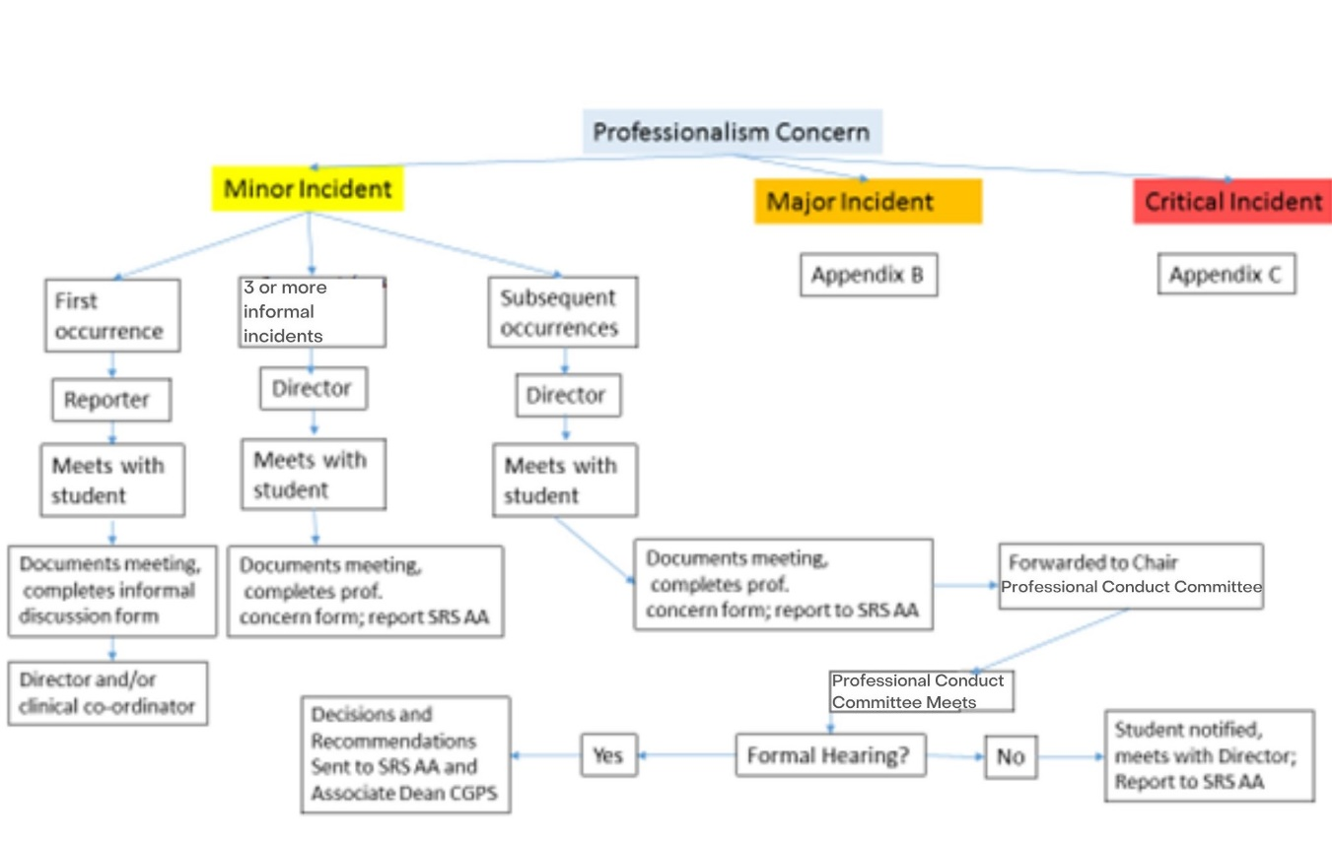

Appendix B: Procedures for Concerns with Physical Therapy Student Professional Behaviour Major Incident

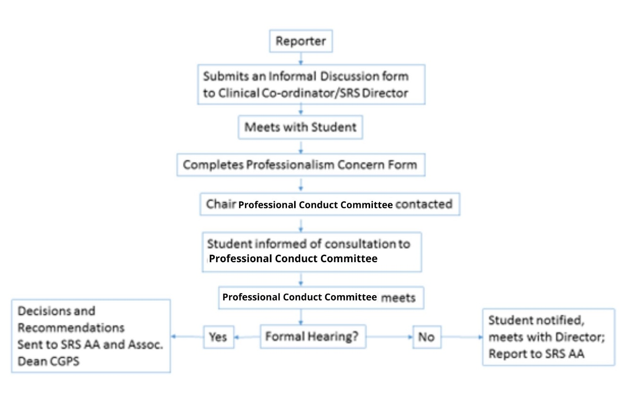
Appendix C: Procedures for Concerns with Physical Therapy Student Professional Behaviour Critical Incident
